Review Sheet
NYS Regents Lab Activity #3
The Beaks of Finches

Important Terms

Variation Competition
Struggle for Survival Adaptation
Environment Selecting Agent
Migration

Key Points

- Species evolve over time. Evolution is a result of the interactions between:
  - The potential for a species to increase its population
  - Genetic variation of offspring due to mutation and genetic recombination.
  - A limited amount of resources in the environment (ex. food, space, mates, etc.)
  - Selection by the environment of those individuals that are better able to survive and produce viable offspring (“survival of the fittest”)

- Some characteristics / variations give individuals an advantage over others in surviving and reproducing. The offspring of these “better adapted” individuals will be more likely to survive and reproduce than those of other individuals. The proportion / frequency of individuals with favorable characteristics will increase.

- Variation in a population increases the likelihood that at least some individuals will survive the changing environmental conditions.

Procedure

- In teams of two, students will simulate competition for food by finches in an island environment.

- The beak variations of finches will be represented by a variety of tools (tweezers, spoons, pliers, etc.)

- In Round One, students simulate feeding on small seeds. Each student will remove seeds alone, without competition from other students.

- The winners of Round One stay on their original island while the losers migrate to a new island with a different food source (large seeds). In Round Two, the same procedure will be followed with one exception. Competition between species will be simulated by having a member from each opposing team feed from the tray at the same time. The winning teams proceed to Round Three and the losing teams are eliminated.

- In Round Three, all surviving teams feeding on large seeds will feed from the same tray of large seeds at the same time. All surviving teams feeding on small seeds will feed on the same tray of small seeds at the same time.

- The winning teams of from Round Three will possess the beak variation that is best fit for feeding on that particular type of seed.

- All trials in each round run for the same length of time. Only those seeds that are successfully removed are counted.

Analysis

- Those individuals with beaks best adapted for feeding on small seeds remained on the island at the end of Round One while those with “less adapted” beaks migrated to a new island.

- Competition for food in Round Two should have had an adverse effect on feeding success.

- There were fewer survivors at the end of Round Three due to increased competition.

- The following four components of Natural Selection were simulated:

  - Variation: different beaks, different size seeds
  - Competition: more than one bird feeding at one bowl
  - Struggle for survival: each bird trying to get enough food to survive
  - Adaptation: particular characteristics of “beaks”
  - Environment: students, seeds, dishes are part of environment
  - Selecting agent: type of “beak” and / or type of seed available

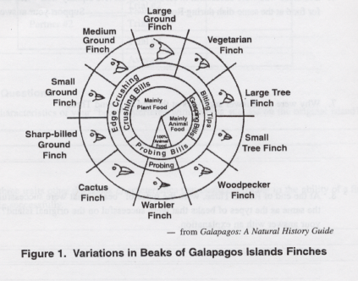
* Be sure you study the diagram to the left that shows the variations in beaks of Galapagos Island finches. The diagram represents the types of beaks, the function of the beaks, and the type of food the finches eat.

